CSCI110 – Fundamentals of Computer Science

MT SAC College

CSCI110

Lab #: 2 A & 2 B____________________

Description: ______________________

______________________

______________________

Due Date: 10/24/2021______________

Name: Austin Ngo__________________

Grade: _______________________

Notes: ______________________

**Lab 2A**

/*

a. Program Description : This program translates a letter grade into a number grade. Letter grades are A,B,C,D,F followed by a + or -. The values are 4,3,2,1 and 0. There is no F+ or F-. The program then outputs the numerical grade for the user.

b. Author : Austin Ngo

c. Input variables : Grade letter and symbol

d. Process Flow : This program takes the letter grade input from the user and translates it into a numeric value for the user.

e. Output variables : Numeric value of grade

*/

#include <iostream>

#include <cmath>

#include <string>

#include <cstdlib>

#include <iomanip>

using namespace std;

int main()

{

string grade;

char letter, symbol;

float score;

cout << "Please enter your grade ";

cin >> grade;

letter = grade[0];

symbol = grade[1];

switch (letter)

{

case 'A': score = 4.0; break;

case 'a': score = 4.0; break;

case 'B': score = 3.0; break;

case 'b': score = 3.0; break;

case 'C': score = 2.0; break;

case 'c': score = 2.0; break;

case 'D': score = 1.0; break;

case 'd': score = 1.0; break;

case 'F': score = 0.0; break;

case 'f': score = 0.0; break;

default: cout << "Wrong input. Please enter a letter grade and symbol." << endl; break;

}

if (score !=0)

{

if (symbol == '+' && score != 4.0)

{

score += 0.3;

}

if (symbol == '-')

{

score -= 0.3;

}

}

cout << "The numeric value of your grade is " << score << "." << endl;

}

**Test Cases 2A**

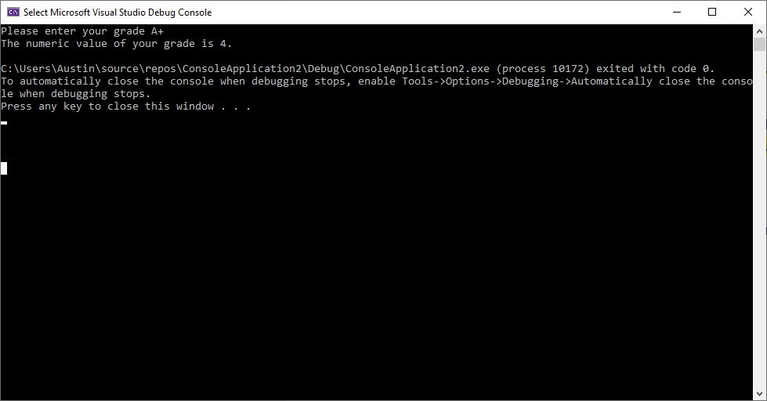

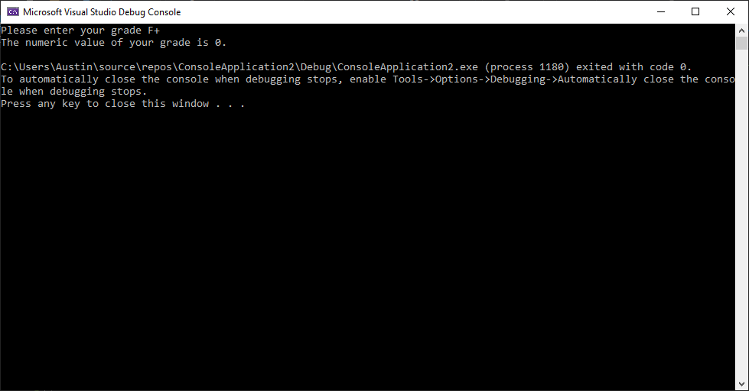

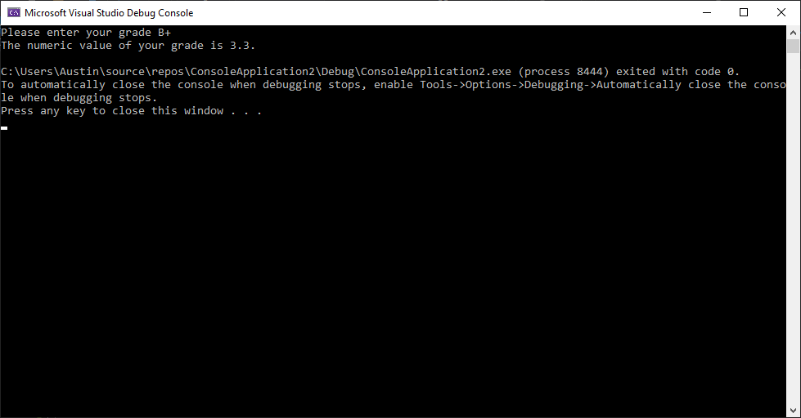

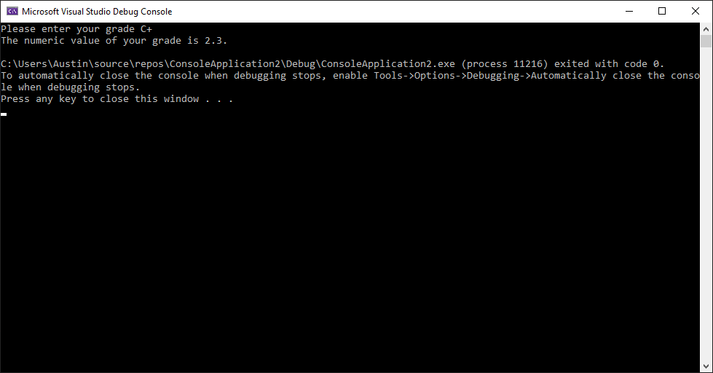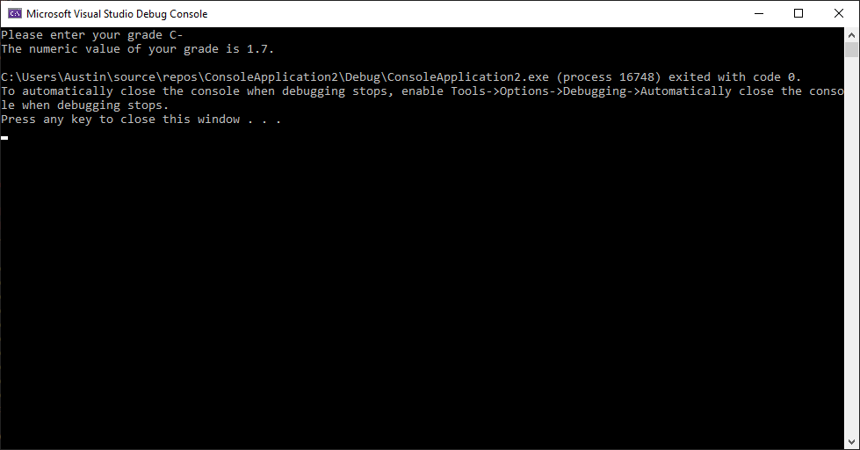

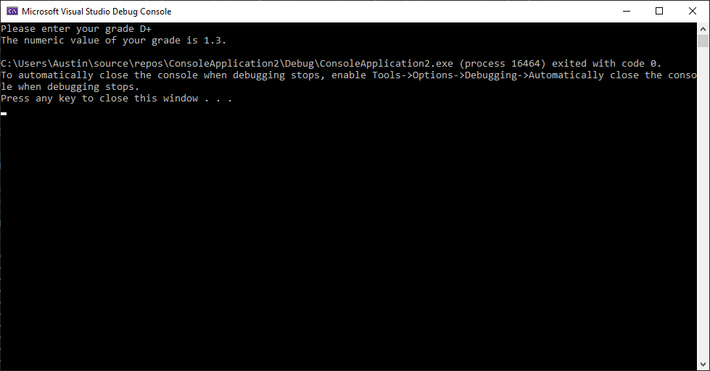

**Lab 2B**

/*

a. Program Description : This program takes a user input word and counts how many syllables the word contains.

b. Author : Austin Ngo

c. Input variables : Words 1-4

d. Process Flow : User inputs words, the program loops for each letter of each word to check for a vowel, then increments the amount of syllables. Double vowels and the letter 'e' at the end of a word do not count towards syllables.

e. Output variables : Syl 1-4.

*/

#include <iostream>

#include <cmath>

#include <string>

#include <cstdlib>

#include <iomanip>

using namespace std;

int main()

{

string word1;

string word2;

string word3;

string word4;

int syl1 = 0;

int syl2 = 0;

int syl3 = 0;

int syl4 = 0;

cout << "Please enter 4 words to find out how many syllables they contain. " << endl;

cin >> word1 >> word2 >> word3 >> word4;

for (int i = 1; i <= 2; i++)

{

if (i == 1)

{

cout << "Words";

}

else if (i == 2)

{

cout << setw(30) << "Syllables" << endl;

}

}

for (int vowels = 0; vowels < word1.length(); vowels++)

{

if ((word1[vowels] == 'a') || (word1[vowels] == 'e') || (word1[vowels] == 'i') || (word1[vowels] == 'o') || (word1[vowels] == 'u') || (word1[vowels] == 'y'))

{

if ((word1[vowels - 1] == 'a') || (word1[vowels] - 1 == 'e') || (word1[vowels] - 1 == 'i') || (word1[vowels] - 1 == 'o') || (word1[vowels] - 1 == 'u') || (word1[vowels] - 1 == 'y'))

{

syl1 = syl1 - 1;

}

syl1 = syl1 + 1;

if (word1[word1.length() - 1] == 'e')

{

syl1 = syl1 - 1;

if (syl1 == 0)

{

syl1 = syl1 + 1;

}

}

}

}

for (int vowels = 0; vowels < word2.length(); vowels++)

{

if ((word2[vowels] == 'a') || (word2[vowels] == 'e') || (word2[vowels] == 'i') || (word2[vowels] == 'o') || (word2[vowels] == 'u') || (word2[vowels] == 'y'))

{

if ((word2[vowels - 1] == 'a') || (word2[vowels] - 1 == 'e') || (word2[vowels] - 1 == 'i') || (word2[vowels] - 1 == 'o') || (word2[vowels] - 1 == 'u') || (word2[vowels] - 1 == 'y'))

{

syl2 = syl2 - 1;

}

syl2 = syl2 + 1;

if (word2[word2.length() - 1] == 'e')

{

syl2 = syl2 - 1;

if (syl2 == 0)

{

syl2 = syl2 + 1;

}

}

}

}

for (int vowels = 0; vowels < word3.length(); vowels++)

{

if ((word3[vowels] == 'a') || (word3[vowels] == 'e') || (word3[vowels] == 'i') || (word3[vowels] == 'o') || (word3[vowels] == 'u') || (word3[vowels] == 'y'))

{

if ((word3[vowels - 1] == 'a') || (word3[vowels] - 1 == 'e') || (word3[vowels] - 1 == 'i') || (word3[vowels] - 1 == 'o') || (word3[vowels] - 1 == 'u') || (word3[vowels] - 1 == 'y'))

{

syl3 = syl3 - 1;

}

syl3 = syl3 + 1;

if (word3[word3.length() - 1] == 'e')

{

syl3 = syl3 - 1;

if (syl3 == 0)

{

syl3 = syl3 + 1;

}

}

}

}

for (int vowels = 0; vowels < word4.length(); vowels++)

{

if ((word4[vowels] == 'a') || (word4[vowels] == 'e') || (word4[vowels] == 'i') || (word4[vowels] == 'o') || (word4[vowels] == 'u') || (word4[vowels] == 'y'))

{

if ((word4[vowels - 1] == 'a') || (word4[vowels] - 1 == 'e') || (word4[vowels] - 1 == 'i') || (word4[vowels] - 1 == 'o') || (word4[vowels] - 1 == 'u') || (word4[vowels] - 1 == 'y'))

{

syl4 = syl4 - 1;

}

syl4 = syl4 + 1;

if (word4[word4.length() - 1] == 'e')

{

syl4 = syl4 - 1;

if (syl4 == 0)

{

syl4 = syl4 + 1;

}

}

}

}

cout << word1 << setw(30) << syl1 << endl;

cout << word2 << setw(30) << syl2 << endl;

cout << word3 << setw(31) << syl3 << endl;

cout << word4 << setw(32) << syl4 << endl;

system("pause");

return 0;

}

**Test Case 2B**

